

DB Linux server validation steps(RAC Server)
Oracle 19c database version

Project



DISCLAIMER

This document is strictly private, confidential and personal to its recipients and should not be copied, distributed or reproduced in whole or in part, nor passed to any third party.

Version history
Date | Version | Description | Author
2022s-05-13 | 1.0 | Initial Version | Kinshuk Ajmera

Introduction

This document describes the steps to validate the server for RAC grid and rdbms installation

validation steps

- Check whether oracle and grid users are created in server and oracle/grid users should be able to switch to root user.
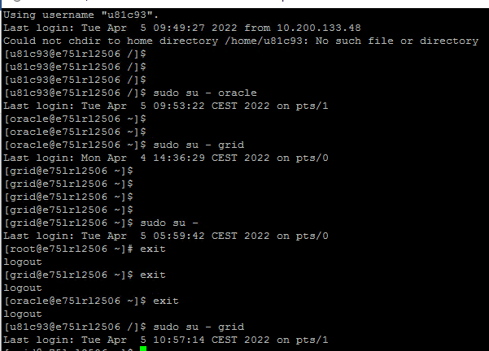

- Check whether below packages are installed.

- Zip/Unzip package • bc
- Binutils • elfutils-libelf-devel
- fontconfig-devel • glibc
- glibc-devel • ksh
- libaio • libaio-devel
- libXrender • libX11
- libXi • libXau
- libXtst • libgcc
- libnsl • librdmacm
- libstdc++ • libstdc++-devel
- libxcb • libibverbs
- smartmontools • make
- sysstat
rpm -qa | egrep -i "Zip|Unzip|bc|binutils|elfutils-libelf|elfutils-libelf-devel|fontconfig-devel|glibc|glibc-devel|ksh|libaio|libaio-devel|libXrender|libX11|libXau|libXi|libXtst|libgcc|libnsl|librdmacm|libstdc++|libstdc++-devel|libxcb|libibverbs|make|smartmontools|sysstat"
rpm -qa | grep -i Zip
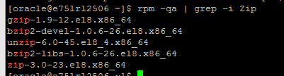

rpm -qa | grep -i Unzip

rpm -qa | grep -i bc
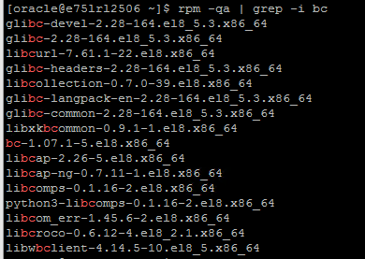

rpm -qa | grep -i binutils
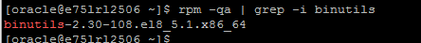

rpm -qa | grep -i elfutils-libelf
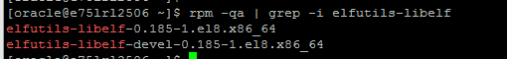
rpm -qa | grep -i elfutils-libelf-devel

rpm -qa | grep -i fontconfig-devel

rpm -qa | grep -i glib
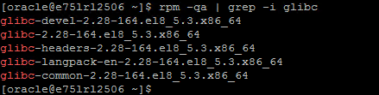c

rpm -qa | grep -i glibc-devel

rpm -qa | grep -i ksh

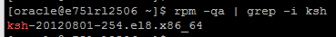
rpm -qa | grep -i libaio
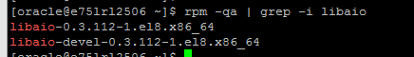

rpm -qa | grep -i libaio-devel
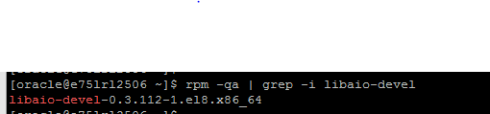

rpm -qa | grep -i libXrender
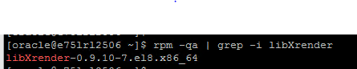

rpm -qa | grep -i libX11
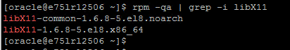

rpm -qa | grep -i libXau
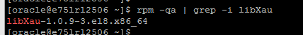

rpm -qa | grep -i libXi

rpm -qa | grep -i libXtst

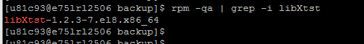
rpm -qa | grep -i libgcc

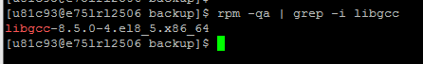
rpm -qa | grep -i libnsl
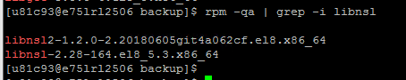

rpm -qa | grep -i librdmacm

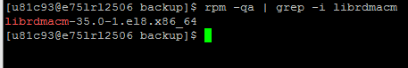
rpm -qa | grep -i libstdc++
rpm -qa | grep -i libstdc++-devel
rpm -qa | grep -i libxcb
rpm -qa | grep -i libibverbs
rpm -qa | grep -i make
rpm -qa | grep -i smartmontools
rpm -qa | grep -i sysstat

<#######################>
rpm -qa | grep -i nettools
rpm -qa | grep -i libvirt

- Check entries in this file /etc/sysctl.conf (Kernel parameter setting) on server
[root@e75lrl2506 bin]#
kernel.shmall = 2251799813685247
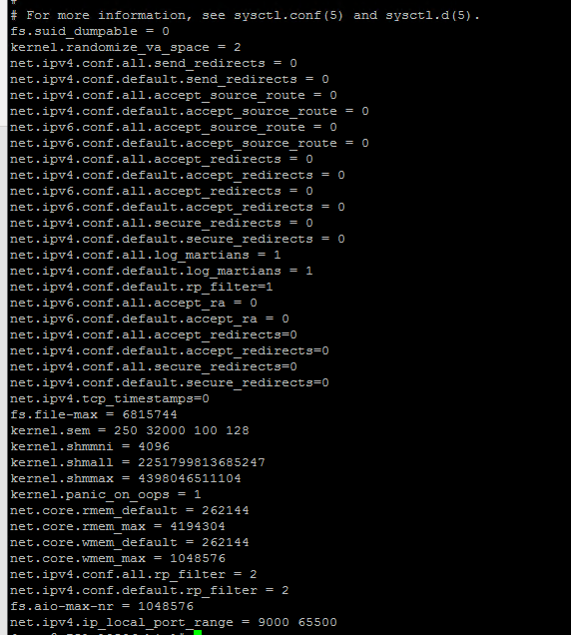

- Check entries in /etc/security/limits.conf on server
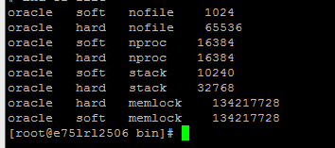

- Check for groups

[root@e75lrl2506 etc]# cat /etc/group

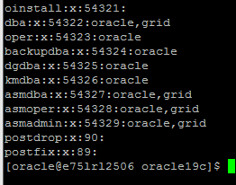

- Local storage on Server
sdf -h

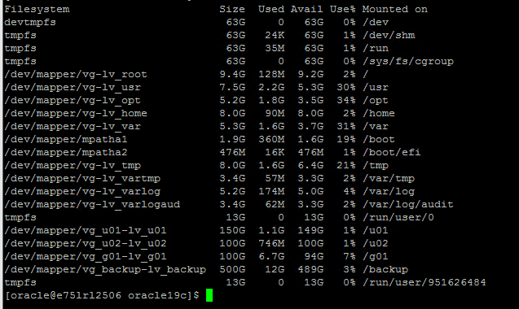

- ASM disks

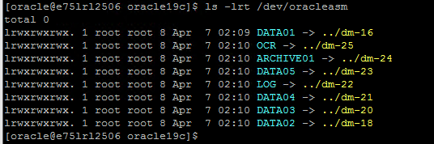

- IP and Hostname should resolve each other

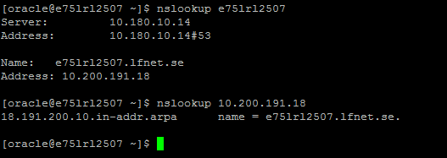

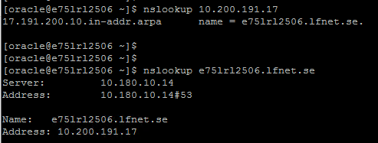

- SELinux parameter should be permissive:
If its enforcing change it to permissive in config file and execute setenforce 0 to make it effective without rebooting the server.
Using getenforce check current value of selinux
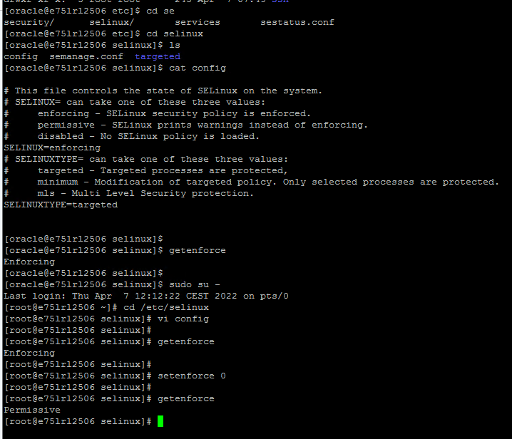

- Check whether firewall opened between catalog server and OEM server, if not raise request accordingly.

- Check swap space. Should be approximately 16G. IF not raise request to unix team to add.

[oracle@e75lrl3089 ~]$ free -g
total used free shared buff/cache available
Mem: 125 1 122 0 1 123
Swap: 15 0 15

- Check open_files parameter for oracle user. It should be 4096
Ullimit -a

- Validate the server date with your system date.
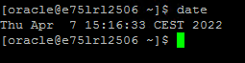

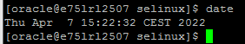

- In case of old server rebuild check the file system uses, service status etc.
ps -ef|grep pmon
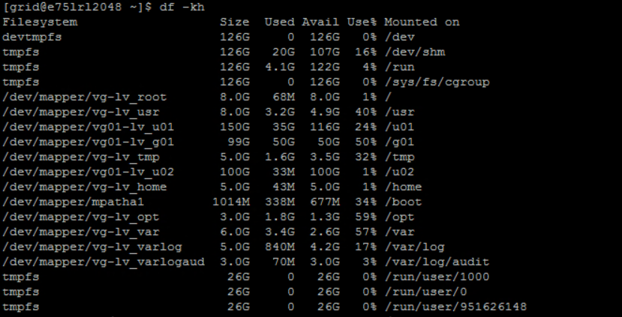

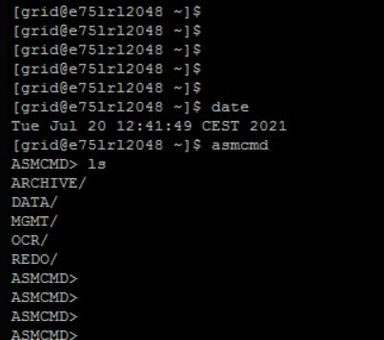

- Check oracle and grid id – check all relevant groups are added to both the users.
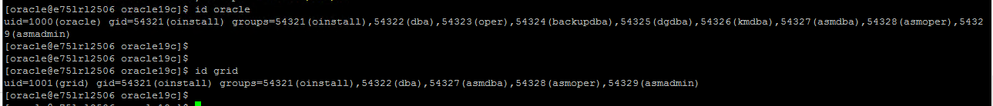

- Check NTPD service:

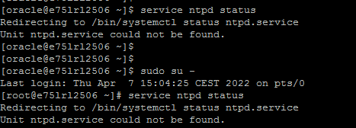

- Set server level default umask value via unix team before proceeding with directory creation.

- Get scan name registered in dNS server. Share scan name with dns team –
Eg – insispt-scan.lfnet.se

Nslookup <scan-name>

Once added in DNS, should be resolvable to three scan ip’s

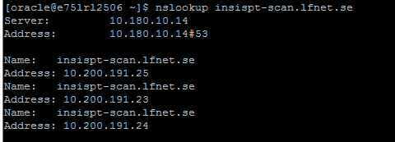

- Add below entry for public ip, private ip and VIP in /etc/hosts file via unix team. Get these ip’s registered in the tool via unix team before adding entry into the file.

[Respective ethernet card for Public and Private interface should be same on both the nodes (Oracle consider ethernet name as case sensitive)]

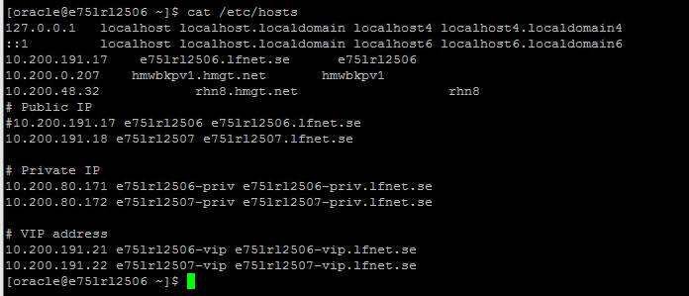

- Once the grid software is unzipped. Execute below command to check pre-requisites for RAC -setup.

[grid@e75lrl2506 oracle19c]$ ./runcluvfy.sh stage -pre crsinst -n e75lrl2506,e75lrl2507 -verbose

[grid@e75lrl2506 oracle19c]$ ./runcluvfy.sh comp clocksync -n all -verbose

END OF DOCUMENT

